Cascade Elementary
IB Approaches to Learning
Distance Learning Choice Board
Day 11 Focus: Communication    Task:  Family Book Club: Start a family book club. Allow everyone to choose a book to read together. Discuss your favorite characters in the book and what part you liked best and why. | Day 12 Focus: Thinking Skills    Task:  Just Journal It: Keep a journal of your adventures during your time away from school.. Record how you feel, why you feel this way, and any needs that you may have as a result of these feelings. | Day 13 Focus: Research Skills    Task:  Quote of the Day: Google “best quotes ever” and find a quote that speaks to you. Write it and tell why it is the best in your opinion. | Day 14 Focus: Communication    Task:  Lyrical Genius: Create a song or poem to express how you are feeling about the current state of the affairs. It can be related to COVID-19, virtual learning or other topics. | Day 15 Focus: Self Management  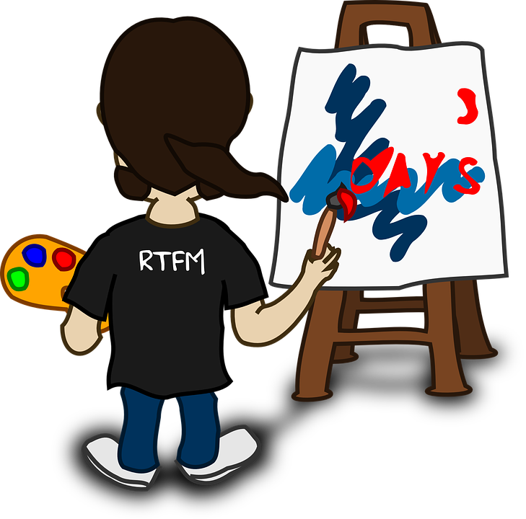  Task:  The Artist in You: Make an art gallery at home. It could be of things you already have or work in art work that you create while out of school. You can add to it over time.
Day 16 Focus: Research Skills    Task:  Oh the Places We'll Go: Research a place you would like to visit. Find out what you could do in this location and plan out a day’s visit. Write down exactly what you would see and the cost of the visit. | Day 17 Focus: Self Management    Task:  Be Creative: Use different clothes to put on a show for your family. Design an outfit and write a play script that you will act out for your family. Invite your siblings to take part. | Day 18 Focus: Social Skills    Task:  Go for a Walk: Ask a parent to walk the neighborhood with you. Try different walking styles: Tip Toe Walk, Heel Walks, Runway Walk, Muscle Man/Woman Walk, Bounce-n-Walk, etc. | Day 19 Focus: Thinking Skills    Task:  Your Voice, Your Choice: Think of something that matters to you in the local or global community. How can you use your voice and your actions to support this matter or to initiate change? Write out a plan that tells what you will do. | Day 20 Focus: Social Skills    Task:  Picnic Time: Plan out an indoor family picnic for your family. Write down the menu, time and who you will invite. After the picnic, write a reflection in your journal.

